Lab 2: Build Skill Flows with GenAI

In this lab, you will create a skill flow with a box and watsonx.ai skill connected. Using this, you will be able to extract the 2023 historic sales for a product for the procurement scenario.

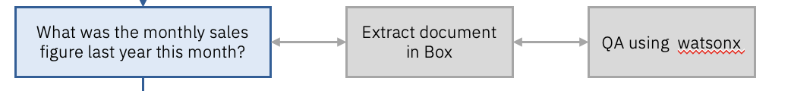

Build a skill flow

In order to build a skill flow, you need to do the following:

1. Add skills in personal skills
2. Create the skill flow
3. Add skills to the skill flow
4. Connect the input and output of skills
5. Enhance and Publish the skill flow

Follow the steps below for detailed instructions.

1. Add skills in personal skills

1.1 Add “Get File Content” Box skill as personal skill [skip this if you have completed lab 1a]

1.2 Add “Content Generation (Async)” watsonx.ai skill as personal skill

1.2.1 Click on chat in the menu bar

1.2.2 Ensure “Personal skills” is selected. Click on “Add skills from the catalog”

1.2.3 Search and click on Content generation app

1.2.4 Click on “Connect app” to connect to the app. Put in the IBM Cloud API key.

1.2.5 Put in the IBM Cloud API Key provided in the Skill Connection Details.docx file and click on connect.

1.2.6 Click on Add Skill + in content generation skill card.

2. Create a skill flow

2.1 Got to “Skills and apps” from the menu bar

2.2 Click on “Create a skill flow”

2.3 Name the skill flow

Click on the edit button. Name the skill to “[Your name] Get Historic Sales Data” and Save.

3. Add skills to the skill flow

3.1 Add input form as first skill.

3.1.1 Click on “+”. Click on “Custom forms” app card.

3.1.2 Click on “Add Skill +” in Input form skill card. The skill will be added in skill flow.

3.2 Add box as the second skill

3.2.1 Click on “+”. Search for box and click on “Box” app card.

3.2.2 Click on “Add Skill +” in the “Get file content” card. The skill will be added in skill flow.

3.3 Add Content Generation as third skill

3.3.1 Click on “+”. Search for content generation and click on “Content generation” app card.



3.3.2 Click on “Add Skill +” in the “Content generation (Async)” skill card. The skill will be added in skill flow.

4. Connect the input and output of skills

4.1 Add User question field in input form

4.1.1 Click on “Input form” card in skill flow and then click on “Add input field +”. Click on “Single line text” radio button and click “Next”.

4.1.2 Add display label as “User Question” and click “Apply”. The input filed will be created.

4.2 Add input and project_id in Content Generation (Async) skill

4.2.1 Click on “Content Generation (Async)” skill and click on “Specify default value” in input field.

4.2.2 Specify the text as below and use the insert variable button to insert variables from other skills.

|  |
| --- |
| Read the context below and answer the question.  Context:  """  <insert content>  """  Question: <insert user question>  Answer: |

4.2.3 Add watsonx.ai project id provided in the Skill Connection Details.docx file as default value in “project_id”.

5. Enhance and Publish skill flow

5.1.1 Click on Enhance Skill. Click on “Save and Close” if prompted.

5.2.2 Go to “Phrases” tab. You can specify any phrases to use to trigger this skill. In this case, ensure “Get historic sales data” is added as a phrase. Click on “Publish”.

Use Skill Flow

1. Add the skill flow in personal skills.

2. Click on the skill flow in Chat to execute it.

3. Ask the question, “What was the monthly sales figure in March?” and click on “Apply”.

4. Select the File “Financial Sales Report Xtralife 2023.txt” and File Type as “Text” and click on “Apply”.

5. The file content will be extracted from box and passed to the Content Generation Skill. Click on “Apply” to run the content generation watsonx.ai skill.

6. The answer to user question would be generated based on the file provided.

